**EXPERIMENT**

The reduced scale facility of a transmission network can be seen in Fig. 1. It consists in 914 meters length grid and two reduced scale distribution substations. Two external loads (a motor and a heating circuit) were connected at two substation and also one partial discharge source for fault generation. High frequency current transformer sensors were used in the signal acquisition process.

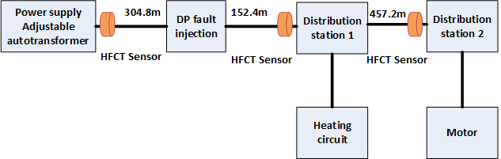

Fig. 1. The experimental facility used for signal acquisition

Fig. 2 shows one of the recorded signals showing all the signals transmitted in the network. There are four categories of electrical signals: a signal from the heating circuit (black ellipse), a fault signal equivalent to a partial discharge (red ellipse), a signal specific to the partial discharge reflection which occurs due to the effects of propagation (brown ellipse) and a signal from the motor (green ellipse).

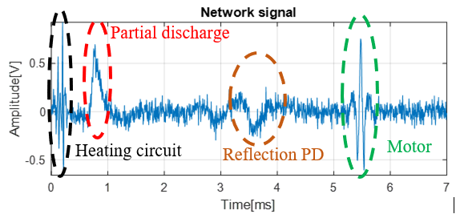

Fig. 2. The signals transmitted in the network

For the database necessary for classification, 1000 signals were recorded at a frequency of 200*MHz*. A signal specific to each of the four classes has 50 samples and is highlighted in Fig. 3.





Fig. 3. The signals specific for the four classes: the motor signal; the heating circuit signal; the partial discharge signal and the reflection signal